OUTPUT:
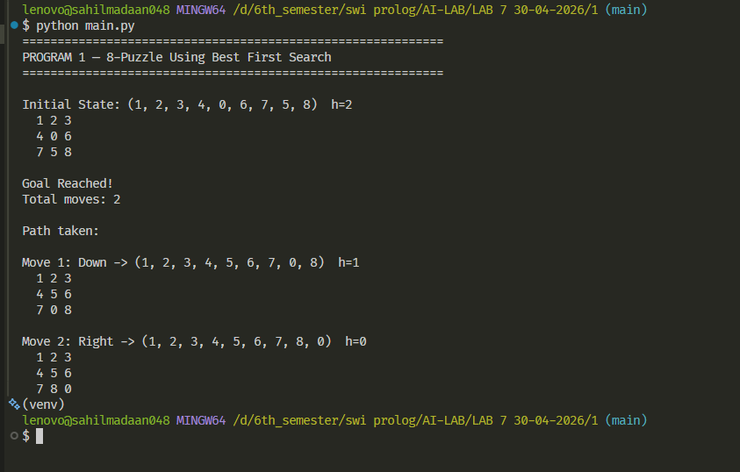

Lab 7
Program 1 — 8-Puzzle (Best First Search)
- Initial: `(1,2,3,4,0,6,7,5,8)`, Goal: `(1,2,3,4,5,6,7,8,0)`
- Heuristic: number of misplaced tiles (excluding blank)
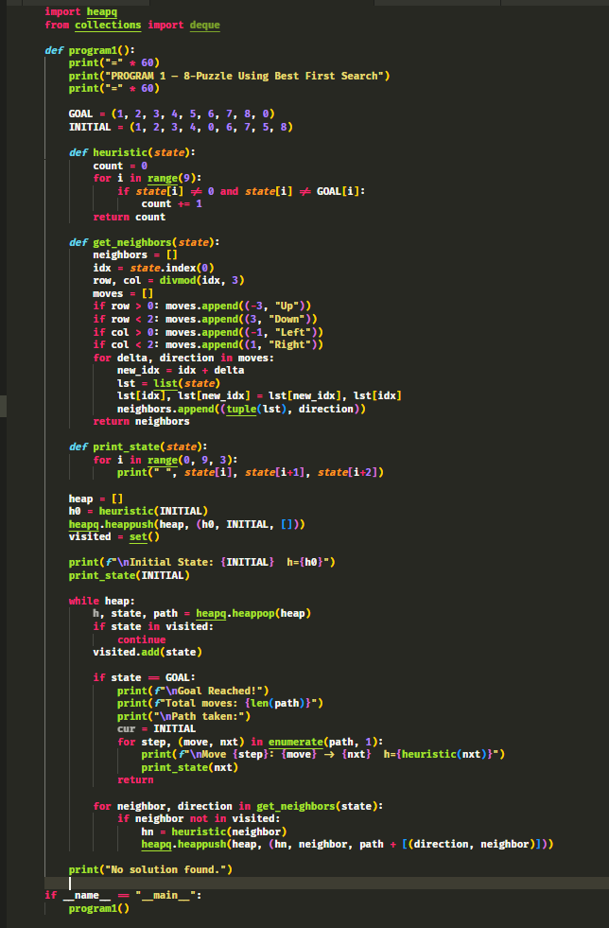
- Print sequence of states from initial to goal

OUTPUT:

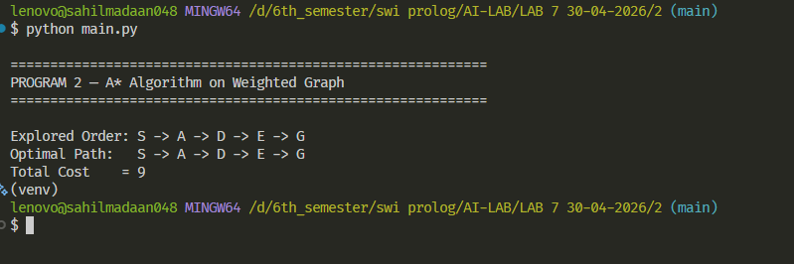

Lab 7
Program 2 — A* on Weighted Graph
- Graph: S→A(3), S→B(5), A→C(4), A→D(2), B→G(9), C→G(7), D→E(1), E→G(3)
- Heuristics: S=10, A=7, B=6, C=5, D=4, E=2, G=0
- Find optimal path S to G, print explored order, path, cost
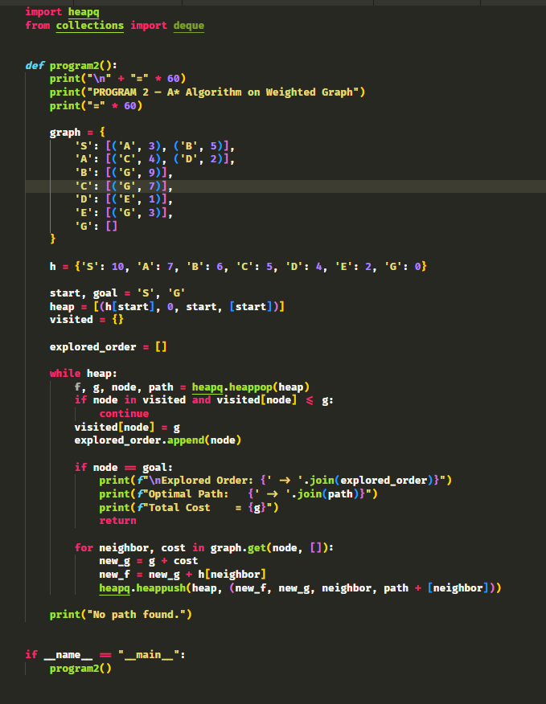

OUTPUT:

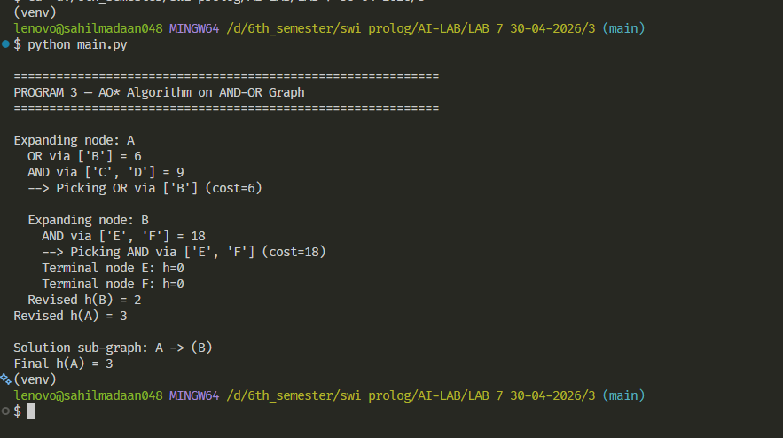

Lab 7
Program 3 — AO* on AND-OR Graph
- Nodes: A, B(h=5), C(h=3), D(h=4), E(h=7), F(h=9). All edge costs=1
- A has: OR→B, AND→(C,D). B has: AND→(E,F). C,D,E,F are terminals
- Print solution sub-graph and cost
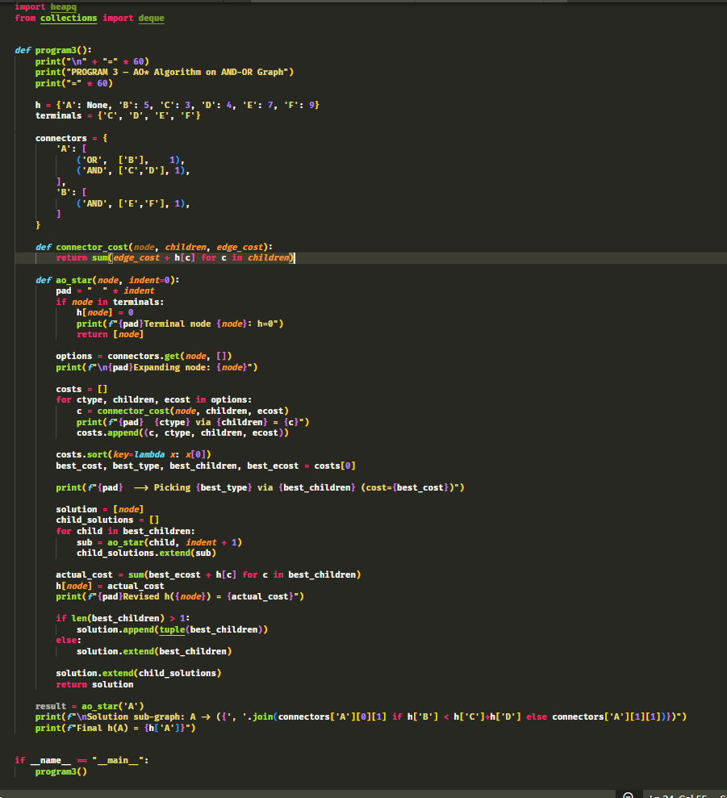

OUTPUT:

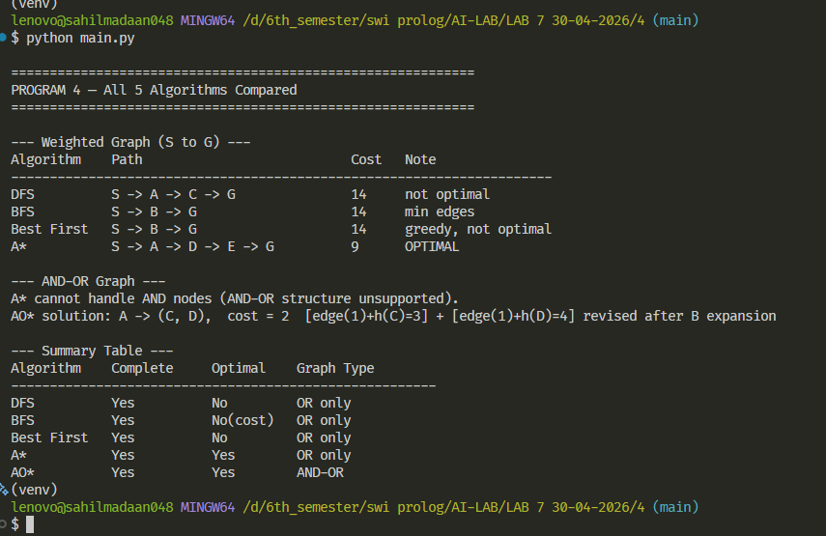

Lab 7
Program 4 — Run All 5 Algorithms
- Run DFS, BFS, Best First, A* on Program 2 graph
- Run AO* on Program 3 graph, try A* on AND-OR (show it fails)
- Tabulate path, cost, observations
